##### A

***MAJOR PROJECT REPORT***

*on*

E-commerce Website

***Submitted in partial fulfillment of the requirements of the degree of***

**BACHELOR OF TECHNOLOGY**



#### Submitted by

Harshit Paneri (18ETCCS041)

Harshit kasodniya (18ETCCS040)

Harshit jain (18ETCCS039)

Vaibhav soni (18ETCCS093)

DEPARTMENT OF COMPUTER SCIENCE AND ENGINEERING

**TECHNO INDIA NJR INSTITUTE OF TECHNOLOGY, UDAIPUR**

RAJASTHAN TECHNICAL UNIVERSITY

May 2022

1



Department of Computer Science and Engineering

Techno India NJR Institute of Technology, Udaipur

#### Certificate

This is to certify that this Major Project report entitled “E-commerce Website**”** by Harshit Paneri, Harshit kasodniya, Harshit jain and Vaibhav soni have completed the work under my supervision and guidance, hence approved for submission in partial fulfillment for the award of degree of Bachelor of Technology in Computer Science and Engineering to the Department of Computer Science and Engineering,

Techno India NJR Institute of Technology, Udaipurduring academic session 2018-2022.

Head of Department

Dept. of CSE, TINJRIT, Udaipur

Date 28 May 2022

2



Department of Computer Science and Engineering Techno India NJR Institute of Technology, Udaipur

#### Examiner Certificate

This is to certify that the following students

Harshit Paneri Harshit kasodniya

Harshit jain

Vaibhav soni

of final year B.Tech (Computer Science and Engineering), were examined for the project work entitled**“** E-commerce Websit**”** during the academic year 2018 - 2022 at Techno India NJR Institute of Technology,Udaipur.

Remarks: Date:

Signature Signature

(**Internal Examiner**) (**External Examiner**)

3

#### ABSTRACT

* **Introduct**
* Computer plays an important role in our daily life. Anything we want we can get only in one mouse click. Speed, reliability and accuracy of the computer make it a powerful tool for different purposes.
* A very important and basic need of today’s modern business world is the quick availability and processing of information usingcomputer. One can easily get the type of required information within a fraction of a second.
* The project that I have taken is also in this category which is used in our daily life whenever we want to purchase some items we can easily get them at our home. E-commerce (electronic commerce) is the buying and selling of goods and services, or the transmitting of funds or data, over an electronic network, primarily the internet.
* These business transactions occur either as business-to-business (B2B), business-to-consumer (B2C), consumerto-consumer or consumer-to- business. The terms e-commerce and e-business are often used interchangeably.
* The term e-tail is also sometimes used in reference to the transactional processesfor online shopping.

4

* Objective
* Developing a GUI based automated Website, which will cover all the information Related to the all products which is used in our daily life. For example – Mobiles Phones, Laptops, Clothes, Books, Electronic Items and many more. So by this GUI based automated website a user want to purchase something then it only a mouse click away to purchase these products.
* The e-commerce is mainly useful for ho haven’t time to go shopping or for comfortably to the customers.
* Those are just entered into this website and bought they want at any time they can visit the web-site. Customer will choose different items like mobile, laptops, etc. This website is based on this formal. Afterchosen items they pay bill thorough pay pal process. Customer will get their items just sitting at home.

#### Needs of Ecommerce

* The “Ecommerce” is developed according the current need in different Fields. This is
* Ecommerce Website which provides facility for purchasing Mobiles, Laptops, tabs and many moreitems. So by using this users which want to purchase some products will first Register an account on the Website then Login through their Username and Password, and then Select items which they want to purchase and add them to cart and finally checkout by giving payment details. So by using this portal users can easily purchase products from their home.

5

#### Scope

* + The main purpose of this model is to facilitate the transfer or supply of goods and services between the online shops and consumers on the basis of the items or goods that the businesssupplies.
  + The primary goal of e-commerce website is to reach maximum customers at the right time to increase sales and profitability of thebusiness.
  + E-commerce website provides multiple benefits to the consumersin form of availability of goods at lower cost,wider choice and saves time.

6

#### PREFACE

The main objective of any computer science student is to get as much of practical knowledge as possible. Being an able to have a practical knowledge by developing a project is a life time experience. As practical knowledge is as important as theoretical knowledge we are thankful of having a project. Through the development of the project we had a great experience of various strategies that can be applied in development of project. This project is the stepping stone for our carrier. We are pleased to present this project. Proper care has been taken while organizing the project so that it is to comprehend also various software engineering concepts as been implemented. We learn to tackle different real-world problems that strike while developing any real-world computer application. In this project report we have included various concept, effects, and implication regarding to our project. This report consists of eight chapters, 1st chapter gives you an introduction about project, titled as “E-Commerce Website” where in this we describe about Characterisitics and Feature’s of E-Commerce .The 2nd chapter of this report mention about the tools and methodology that we have use for developing the project. The 3rd chapter brings information about all the design of our project. In 4th chapter we discuss about the Data Workflow of our project. In 5th chapter provide an idea about how the website works. And the last we mention the conclusion, Future scope, etc. During this project session we come to know how to work in a group and what discussion are made about real world objects and problems arise during development phase. And also, weget an idea how to develop a real-world project in different modules and then combined them the main application. We also work on a new platform; we had acquired sound experience of team work and practical knowledge. Also learn that how to use web application. This platform is very different for using in our project session. When we work on this, we faced many difficulties but we find solutions of these difficulties.

7

#### ACKNOWLEDGEMENT

It gives me immense pleasure to express my deepest sense of gratitude and sincere thanks to my highly respected and esteemed guide **Mr. Aaditya Maheshwari , Head - Industry Projects** for their valuable guidance, encouragement and help for completing this work. Their useful suggestions for this whole work and co-operative behavior are sincerely acknowledged.

I would like to express my sincere thanks to < **Head of Department Name>** **Head of Department, Department of computer Science and engineering (TINJRIT)** for giving me this opportunity to undertake this project.

I also wish to express my indebtedness to my parents as well as my family member whose blessings and support always helped me to face the challenges ahead.

At the end I would like to express my sincere thanks to all my friends and others who helped me directly or indirectly during this project work.

Place: Udaipur Date: 28 May 2022

Harshit Paneri (18ETCCS041)

Harshit kasodniya (18ETCCS040)

Harshit jain

(18ETCCS039)

Vaibhav soni

(18ETCCS093)

8

# Table of contents –

* Abstract
* Acknowledgement
* Table of Contents
* List of Tables
* List of Figures

Chapter-1

* Introduction

1. Introduction and objective of the project
2. Objective Review
3. Scope
4. History of E -Commerce
5. Characteristics/features of e- commerce
6. The Future of Ecommerce

Chapter-2

* **Software Requirement Specification**
  1. Functionality
  2. E-Commerce high level process Workflow
  3. Software Requirements Chapter-3
* **System Analysis and Design**

1. Profile of Problems
2. B2C Model
3. Methodology Development Model
   * Requirement Gathering and analysis
   * System Design
   * Implementation
   * Integration and Testing
   * Deployment of system
   * Maintenance

9

Chapter-4

* **Data Dictionary**

1. User Process Model Workflow
2. Data flow diagram-0
3. Data flow diagram-1
4. Structure of the project
   * Before Login
   * After Administrator Login Edit Website Details
   * After User Login My Profile

Chapter-5

* **Screen Shots - E-commerce website**
  + Login And Register Section
  + Home Section
  + Products Section
  + Products Price Section
  + Rating section
  + Select the category
  + Products Browsing
  + Search products
  + Products Create by Admin
  + Contact section
  + About Section
  + Header
  + Footer

Chapter-6

* **Testing**

Chapter-7

* **Conclusion and Future Enhancements**

Chapter-8

* **Bibliography**

10

**List of Figures**

|  |  |  |
| --- | --- | --- |
| **Figure No.** | **Figure Name** | **Page No.** |
|  |  |  |
| Figure 1 | High level process Workflow | 20 |
| Figure 2 | Concepts of Node.Js | 23 |
| Figure 3 | B2C MODEL | 29 |
| Figure 4 | Flowchart of Ecommerce | 30 |
| Figure 5 | Methodology Development Model | 31 |
| Figure 6 | Sequence Diagram | 33 |
| Figure 7 | Data flow-0 diagram | 35 |
| Figure 8 | User Process Model Workflow | 36 |
| Figure 9 | Data flow-1 diagram | 37 |
| Figure 10 | Use case Diagram of Ecommerce | 38 |
| Figure 11 | Use-Case diagram for User | 39 |
| Figure 12 | User Flow diagram | 40 |
| Figure 13 | Use-Case diagram for Admin | 41 |
| Figure 14 | Entity-relationship diagram | 42 |
|  |  |  |

11

***CHAPTER – 1. INTRODUCTION***

12

***E-commerce Website***

* Introduction and objective of the project
  + Project Description
* An E-Commerce portalwhich will allow formal and informal merchantsin developing countries to advertise and sell their goods on the internet.
* This would permit rural communities to make their wares available to the rest of the world via the World Wide Web.The objectiveof this project is to create an e-commerce website with a content management system.
* The website will have an online interface in the form of an e-commerce website that will allow users to buy goods from the merchants.
  + Objective Review:
* It's a website for online shopping .
* Admin maintain whole process of management.
* Administrator ,Users here on this E –Commerce website.
* users visit this E –Commerce online shopping & place order .
* User must go to website and select products .
* After finished the order , Product manager delivery the product .

13

* + Scope
* The main purpose of this model is to facilitate the transfer or supply of goods and services between the online shops and consumers on the basis of the items or goods that the businesssupplies.
* The primary goal of e-commerce website is to reach maximum customers at the right time to increase sales and profitability of thebusiness.
* E-commerce website provides multiple benefits to the consumersin form of availability of goods at lower cost,wider choice and saves time.

14

History of e-E-Commerce

* Originally, electronic commerce meant the facilitation of commercial transactions electronically, using technology such as Electronic Data Interchange (EDI) and Electronic Funds Transfer (EFT). These were both introduced in the late 1970s, allowing businessesto send commercial documents like purchase orders or invoices electronically.
* Online shopping, a form of electronic commerce, In 1979 Michael Aldrich, an English inventor, connected a modified 26″ color domestic television to a real-time transaction processing the computer via a domestic telephone line and invented online shopping. The first recorded B2B was Thomson Holidays 1981 the first recorded B2C was Gateshead SIS/Tesco in 1984. The world’s first recorded online home shopper was Mrs.Jane Snowball, 72, of Gateshead, England in May 1984. During the 1980s Aldrich sold many systems mainly in the UK including Ford, Peugeot, General Motors and Nissan.
* The Nissan system of 1984/5 was revolutionary. It enabled a car buyer on a dealer’s lot to both buy and finance the car, including a credit check, online. Aldrich invented both the online shopping system and the business rationale for using it. His 1980s systems were as fast as 2010 internet shopping systems. They used dial-up and leased telephonelines as broadband was not available
* From the 1990s onwards, electronic commerce would additionally include enterprise resource planning systems (ERP), data mining and data warehousing.
* An early example of many-to-many electronic commerce in physical goods was the Boston Computer Exchange, a marketplace for used computers launched in 1982. Anearly online information marketplace, including online consulting, was the American Information Exchange, another pre Internet online system introduced in 1991.
* The Internet became popular worldwide around 1994 when the first internet online shopping started; it took about five years to introduce security protocols and DSL allowing continual connection to the Internet. By the end of 2000, many European and American business companies offered their services through the World Wide Web. Sincethen people began to associate the word “eCommerce” with the ability to purchase various goods through the Internet using secure protocols and electronic payment services.

15

* **Characteristics/features Of E- Commerce:—**

E-Commerce provides the following features —

* **Non-Cash Payment** — E-Commerce enables the use of credit cards, debit cards, smart cards, electronic fund transfer via bank's website, and other modes of electronics payment.
* **24x7 Service availability** — E-commerce automates the business of enterprises and the way they provide services to their customers. It is available anytime, anywhere.
* **Advertising / Marketing** — E-commerce increases the reach of advertising of products and services of businesses. It helps in better marketing management of productsrsenices.
* **Improved Sales** — Using e-commerce, orders for the products can be generated anytime, anywhere without any human intervention. It gives a big boost to existing sales volumes.
* **Support** — E-commerce provides various ways to provide pre-sales and post- sales assistance to provide better services to customers.
* **Inventory Management** — E-commerce automates inventory management. Reports get generated instantly when required. Product inventory management becomes very efficient and easy to maintain.
* **Communication improvement** — E-commerce provides ways for faster, efficient, reliable communication with customers and partners.

16

#### The Future of Ecommerce

* + - By 2022, ecommerce revenue in the U.S. alone is expected to reach $479 billion, with the toys, hobby and DIY vertical seeing the largest growth.
    - And it's no passing trend, either. It's also interesting to note that looking ahead, ecommerce expert Gary Hoover's data projects that ecommerce retail sales will eventually even out with that of brick and mortar.
    - This means that even thoughthe online sales trend will continue to grow, there's plenty of business to go around.But that's not all. Soon, most ecommerce interactions will be an omni- channel experience for shoppers.
    - This means they'll expect to be able to research, browse, shop, and purchase seamlessly between different devices and on different platforms (like a standalone web store, an Amazon presence, etc.).

###### Other trends to watch for in the future of ecommerce include:

* Robust customer journeys and personalization.
* Artificial intelligence-enabled shopping.
* Digital currencies.

Overall, we have to remember that ecommerce is still fairly new in the bigpicture of retail. The future holds endless opportunity, but its success and continuation will depend largely on buyers' preferences in the future.

17

## CHAPTER –2.

***Software Requirement Specification***

18

* + **Functionality**
* Menu Category
* Category list
* Product list
* Category Management
* Product browsing
* Shopping cart Checkout
* Search products
* Contact us

19

* + TOOLS AND METHODOLOGIES
* *E-Commerce high level process Workflow*

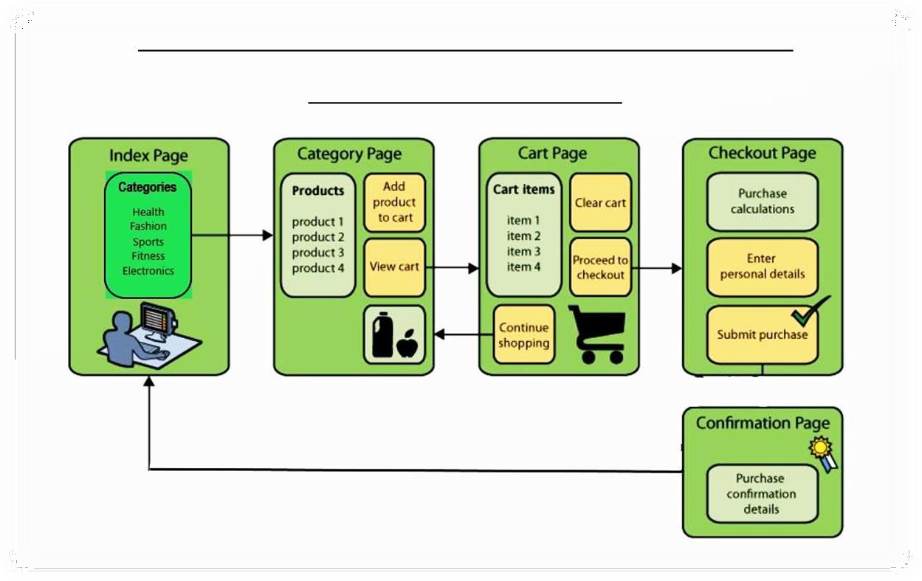

**Fig.1: High level process Workflow**

20

* + **TOOLS AND METHODOLOGIES**

Now we will be describing all the languages, platforms tools and technologies are used in orderto complete this project.

**1. Node JS**

What is Node.Js?

* Node.Js is a server-side platform built on Google Chrome's JavaScript Engine (V8 Engine).Node.Js was developed by Ryan Dahl in 2009.
* its latest version is v0.10.36.Node.Js is an open source, cross-platform runtime environment for developing server-side and networking applications.
* Node.Js applications are written in JavaScript, and can be run within the Node.Js runtime on OS X, Microsoft Windows, and Linux.
* Node.Js also provides a rich library of various JavaScript modules which simplifies the development of web applications using Node.Js to a great extent.

**Node.Js = Runtime Environment + JavaScript Library 12**

21

o Features of Node.Js:

Following are some of the important features that make Node.Js the first choice of software architects.

1. **Asynchronous and Event Driven-** All APIs of Node.Js library are asynchronous, that is, non- blocking. It essentially means a Node.Js based server never waits for an API to return data. The server moves to the next API after calling it and a notification mechanism of Events of Node.Js helps the server to get a response from the previous API call.
2. **Very Fast-** Being built on Google Chrome's V8 JavaScript Engine; Node.Js library is very fast in code execution.
3. **Single Threaded but Highly Scalable-** Node.Js uses a single threaded model with event looping. Event mechanism helps the server to respond in a non- blocking way and makes the server highly scalable as opposed to traditional servers which create limited threads tohandle requests. Node.Js uses a single threaded program and the same program can provide service to a much larger number of requests than traditional servers like Apache HTTP Server.
4. **No Buffering** − Node.Js applications never buffer any data. These applications simply output the data in chunks.
5. **License** − Node.Js is released under the MIT license

Who uses Node.Js?

Node.Js is used by eBay, General Electric, Go Daddy, Microsoft, PayPal, Uber, Wiki pins, Yahoo!, and Yammer to name a few. Projects, Applications, and Companies Using Node.

22

###### o Concepts:

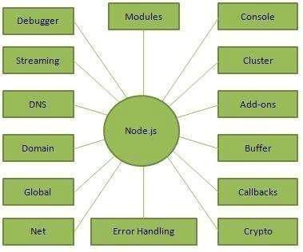

The following diagram depicts some important parts of Node.Js which we will discuss in detail in the subsequent.

**Fig. 2 – Concepts of Node.Js**

Where do we use Node.Js?

Following are the areas where Node.Js is proving itself as a perfect technology partner.

* 1. I/O bound Applications
  2. Data Streaming Applications
  3. Data Intensive Real-time Applications (DIRT)
  4. JSON APIs based Applications
  5. Single Page Applications
  6. It is not advisable to use Node.Js for CPU intensive applications

23

#### React Js

* 1. ReactJS is JavaScript library used for building reusable UI components. According to React officialdocumentation, following is the definition
  2. React is a library for building composable user interfaces. It encourages the creation of reusable UIcomponents, which present data that changes over time. Lots of people use React as the V in MVC.React abstracts away the DOM from you, offering a simpler programming model and better performance. React can also render on the server using Node, and it can power native apps using React Native. React implements one-way reactive data flow, which reduces the boilerplate and is easier to reason about than traditional data binding.

#### React Features

* JSX − JSX is JavaScript syntax extension. It isn't necessary to use JSX in React development, but it is recommended.
* Components − React is all about components. You need to think of everything as a component. This will help you maintain the code when working on larger scale projects.
* Unidirectional data flow and Flux − React implements one-way data flow which makes it easy to reason about your app. Flux is a pattern that helps keeping yourdata unidirectional.

#### React Advantages

* Uses virtual DOM which is a JavaScript object. This will improve apps performance,since JavaScript virtual DOM is faster than the regular DOM.
* Can be used on client and server side as well as with other frameworks.
* Component and data patterns improve readability, which helps to maintain largerapps.

#### React Limitations

* Covers only the view layer of the app, hence you still need to choose othertechnologies to get a complete tooling set for development.
* Uses inline templating and JSX, which might seem awkward to some developers.

24

#### Express

Express is a minimal and flexible Node.js web application framework that provides a robust set of features to develop web and mobile applications. It facilitates the rapid development of Node based Web applications. Following are some of the core features of Express framework −

* + - Allows setting up middleware’s to respond to HTTP Requests.
    - Defines a routing table which is used to perform different actions based on HTTP Methodand URL.
    - Allows to dynamically rendering HTML Pages based on passing arguments to templates.

**$ npm install express –save**

The above command saves the installation locally in the node modules directory and creates a directory express inside node modules. You should install the following important modules along with express −

**Body-parser −** This is a node.js middleware for handling JSON, Raw, Text and URL encoded form data.

**Cookie-parser −** Parse Cookie header and populate req.cookies with an object keyed by the cookie names.

**Multer −** This is a node.js middleware for handling multipart/form-data

25

* 1. **MongoDB**

MongoDB is an open-source document database and leading No SQL database. MongoDB is written in C++. This tutorial will give you great understanding on MongoDB concepts needed to create and deploy a highly scalable and performance-oriented database.

Audience

This tutorial is designed for Software Professionals who are willing to learn MongoDB Database in simple and easy steps. It will throw light on MongoDB concepts and after completing this tutorial you will be at an intermediate level of expertise, from where you can take yourself at higher level of expertise.

Prerequisites

Before proceeding with this tutorial, you should have a basic understanding of database, text editor and execution of programs, etc. Because we are going to develop high performance database, so it will be good if you have an understanding on the basic concepts of Database (RDBMS).

* Software Requirements

At Developer End

* + Front-end : HTML, CSS, JavaScript,React.js
  + Back –end : Node.js, Express.js
  + OS : Window 7 or above, Linux or any other
  + Database : Mongodb
  + IDE : Visual Studio Code At User End
  + Any latest web enabled browser

26

## CHAPTER –3.

***System Analysis and Design***

27

* **Profile of Problems :**
* One must know what the problem is before it can be solved. The basis for ecommerce is to buy products online and save the timing.
* A Ecommerce, who want to buy any product of their need, has to contact different Shoppers, before deciding upon a particular Product that best suit his needs, requirements and satisfaction. Moreover, most of the work involved in thisdevelopment process has to be done manually which is very time consuming and cumbersome and also, it reduces the efficiency, accuracy.
* To know the facts and understanding of the problem in detail, System Analysis is carried out. It is the process of studying the business processes and procedures, generally referred to as business systems, to see how they can operate and whether improvement is needed.

#### B2C Model

* Business — to Consumer [B2C] e-commerce consists of the saleof products or services from a business to the general public.
* Products can be anything from clothing to flowers and the products can also be intangible products such as online banking,stock trading, and airline reservations. Sellers that use B2C business model can increase their benefits by eliminating the middlemen. This is called disintermediation because businessessell products directly to consumers without using traditional retail channels.
* Business — to Consumer [B2C] is basically a concept of online marketing and distributing of products and services over the internet.

28

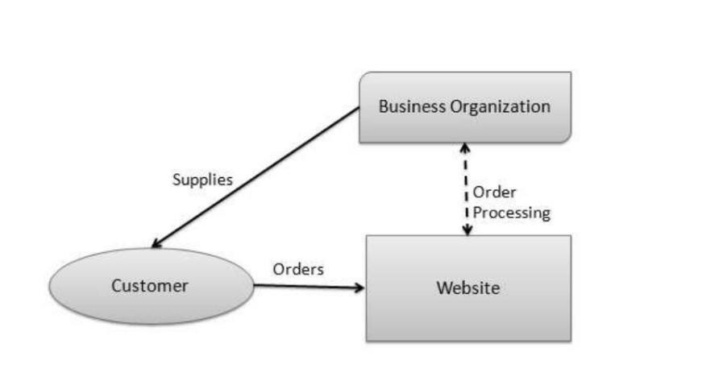

* B2C MODEL

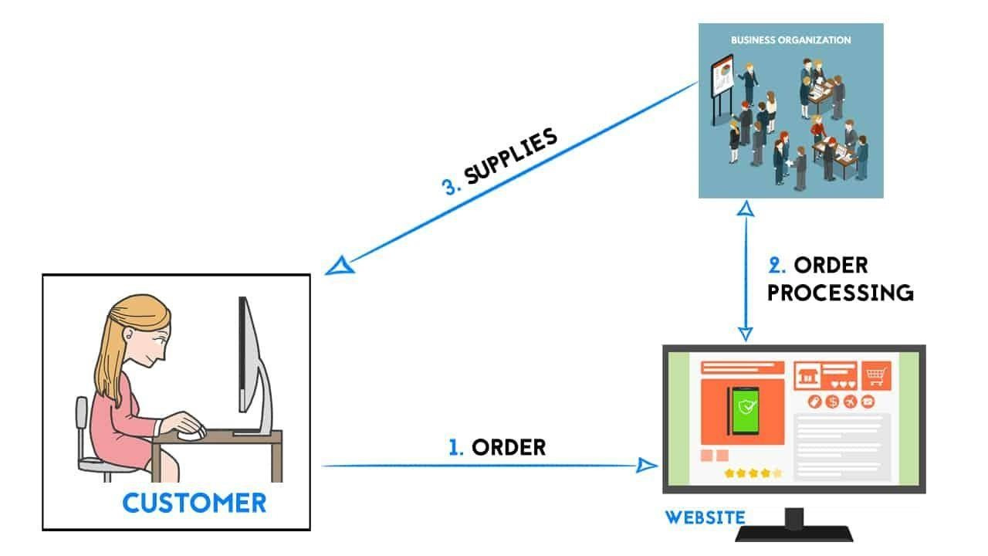

**Fig.3: B2C MODEL**

29

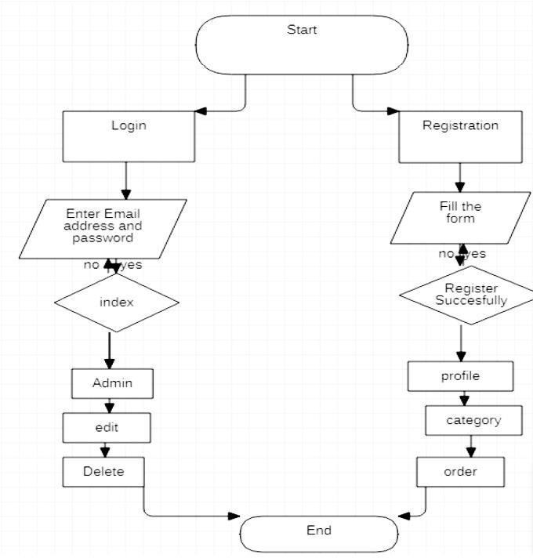

Fig.4: Flowchart of Ecommerce

30

#### Methodology Development Model

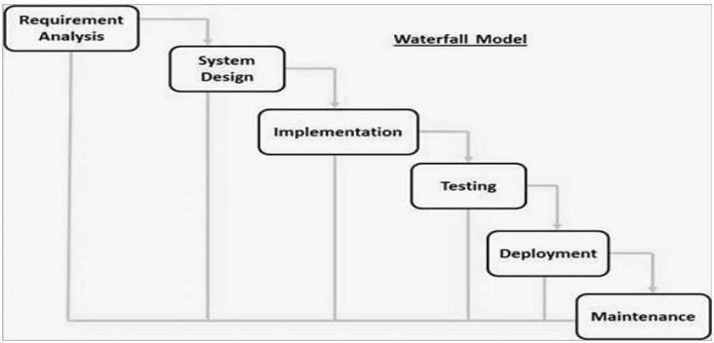

**Fig.5: Methodology Development Model**

The sequential phases in Waterfall model are –

o **Requirement Gathering and analysis** − All possible requirements of the system to be developed are captured in this phase and documented in a requirement specification document.

31

* **System Design** – The requirement specifications from first phase are studied in this phase and the system design is prepared. This system design helps in specifying hardware andsystem requirements and helps in defining the overall system architecture.
* **Implementation** − With inputs from the system design, the system is first developed in small programs called units, which are integrated in the next phase.Each unit is developed and tested for its functionality, which is referred to as UnitTesting.
* **Integration and Testing** − All the units developed in the implementation phase are integrated into a system after testing of each unit. Post integration the entiresystem is tested for any faults and failures.
* **Deployment of system** − Once the functional and non-functional testing is done;the product is deployed in the customer environment or released into the market.
* **Maintenance** − There are some issues which come up in the client environment. To fix those issues, patches are released. Also to enhance the product some better versions are released. Maintenance is done to deliver thesechanges in the customer environment.

32

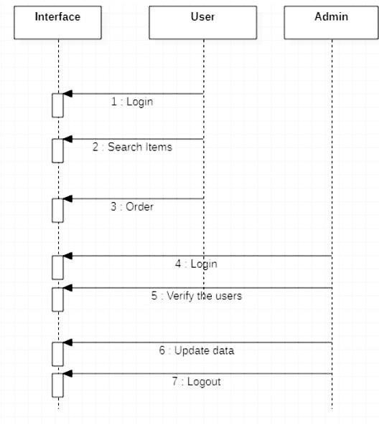

**Fig.6: Sequence Diagram**

33

## CHAPTER –4.

***Data Dictionary***

34

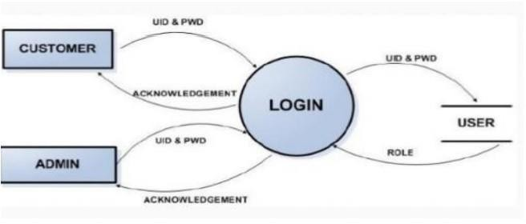

**Fig.7 : Data flow - 0**

35

* + User Process Model Workflow

o A Process Model tells us about how the data is processed and how the dataflows from one table to another to gather the required information. This model consists of the Functional Decomposition Diagram and Data Flow Diagram.

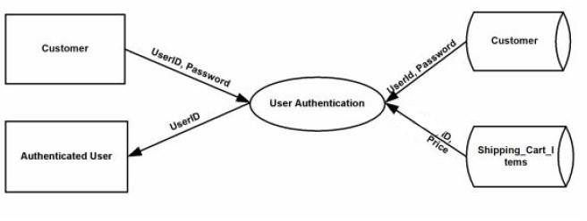

**Fig.8: User Process Model Workflow**

36

###### Data flow diagram -

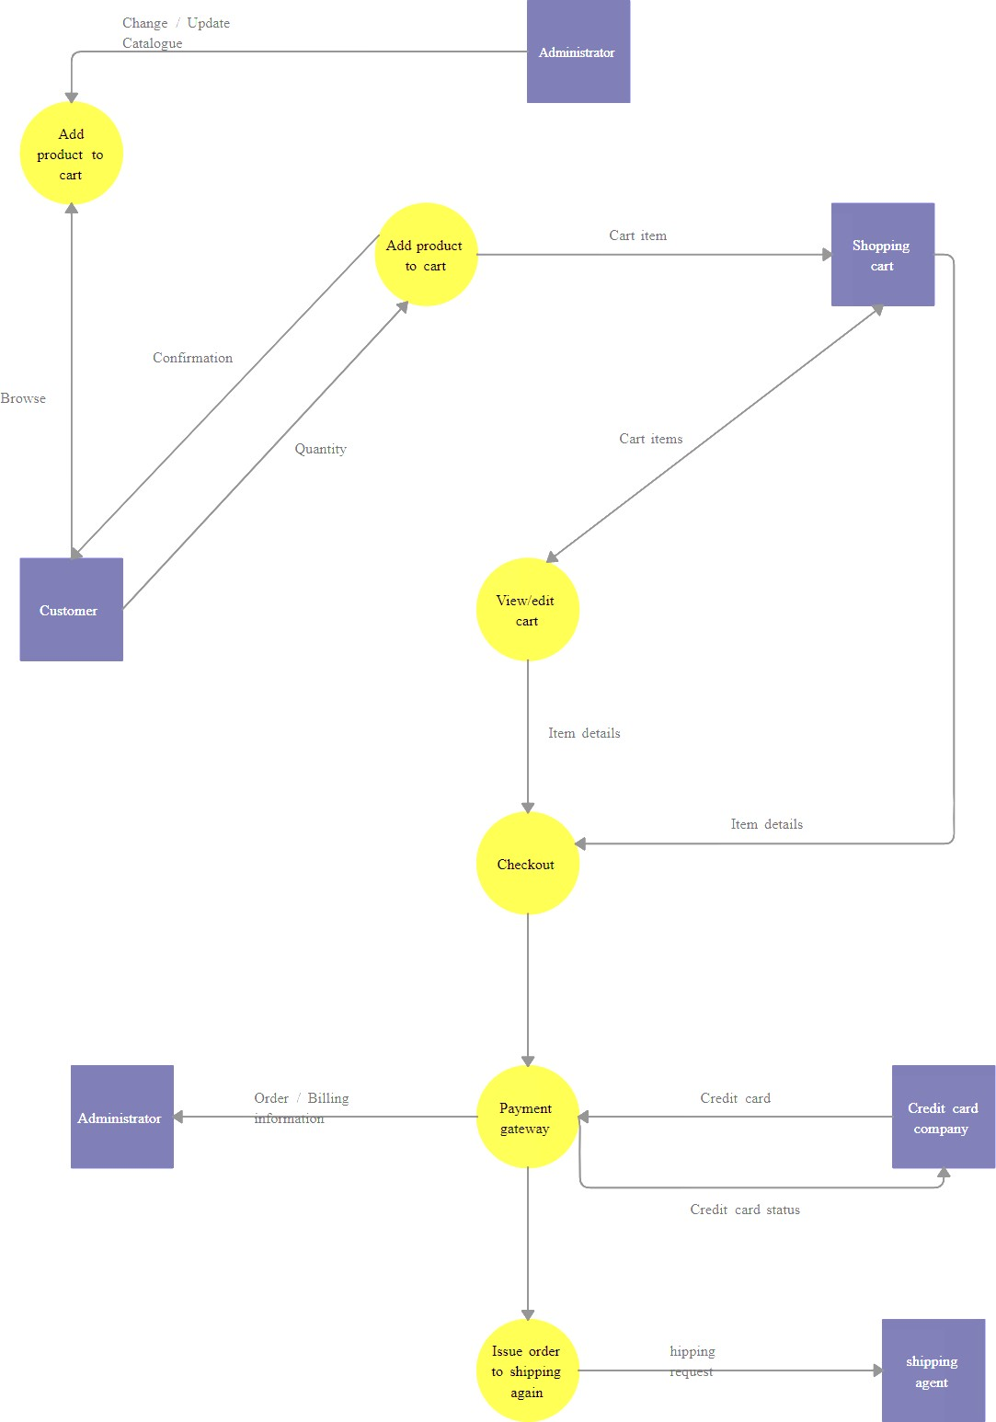

**Fig.9: Data flow-1 diagram**

37

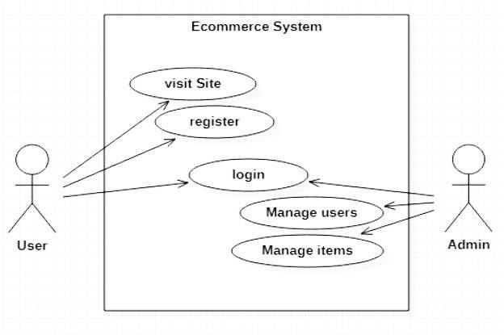

**Fig.10: Use case Diagram of Ecommerce**

38

## Use-Case diagram for User

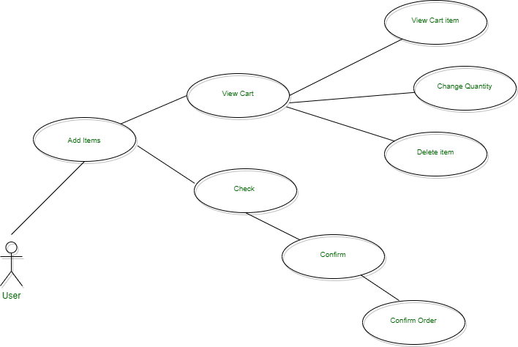

**Fig.11: Use-Case diagram for User**

39

* 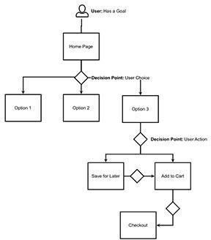User Flow -

**Fig.12: User Flow diagram**

40

* *Use-Case diagram for Admin*

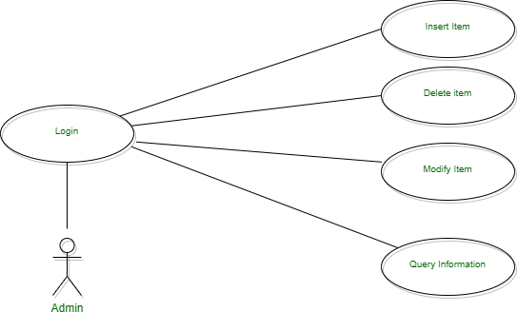

**Fig.13: Use-Case diagram for Admin**

41

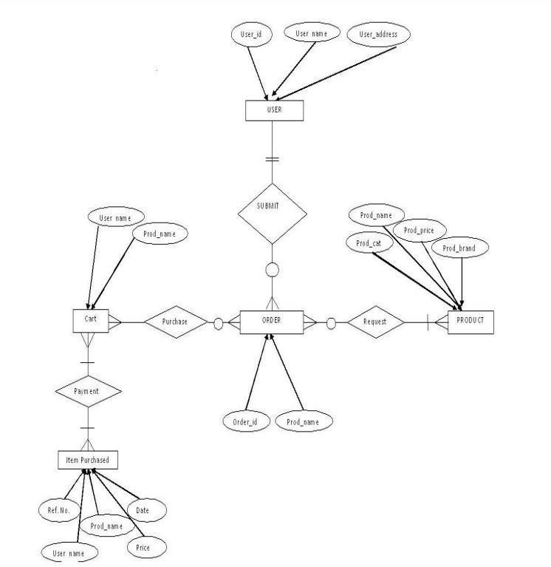

**Fig.14: Entity-relationship diagram**

42

## Structure of the project

##### Before Login

###### Login

* Register

###### Forgot Password

* Administrator Login

###### About Us

* Contact Us

##### After Administrator Login Edit Website Details

###### Add Category Add Items

* Delete Brands Delete Category Delete Items

###### Manage Brand

* See Users

###### Users Shopping

* Add Users

###### Delete Users

* Logout

43

##### After User Login My Profile

###### Edit Profile

* + Change Password

###### Buy Products

* + Categories (Controlled by Admin. Which can be add it dynamically according to their needs)

###### My Cart

* + My Shopping’s

###### Checkout

* + Logout

44

## CHAPTER –5.

***Screen Shots***

45



* Login And Register Section

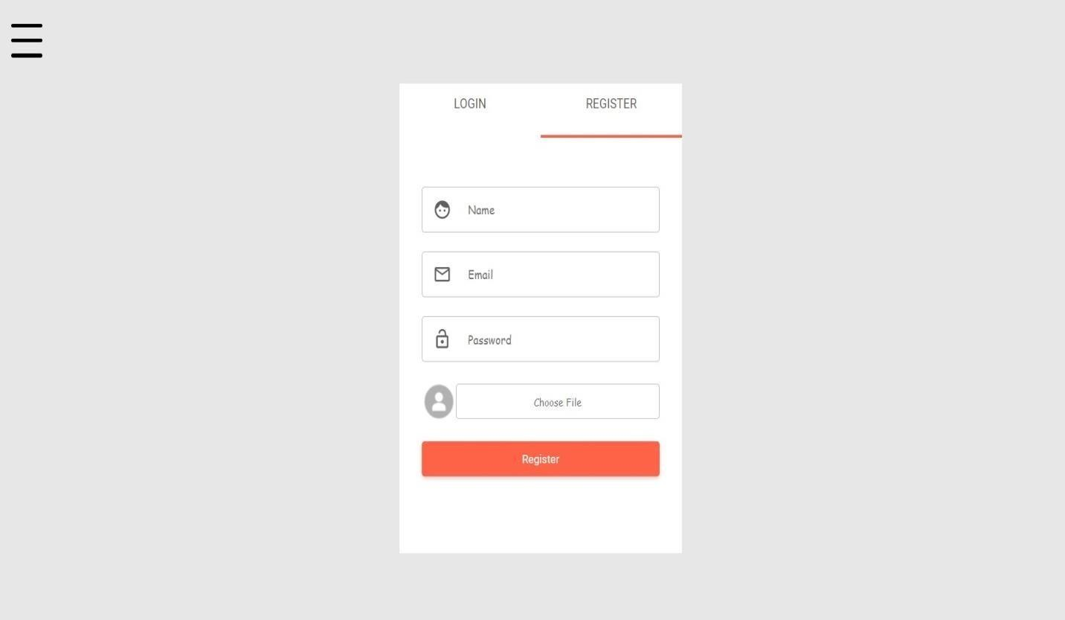

46

### Home Section

* + The home page is the name of the main page of a website where visitors can findhyperlinks and functionality to find other pages.
  + Visitor navigating to a website from a search engine will see.
  + And it may also serve as a landing page to attract visitors.

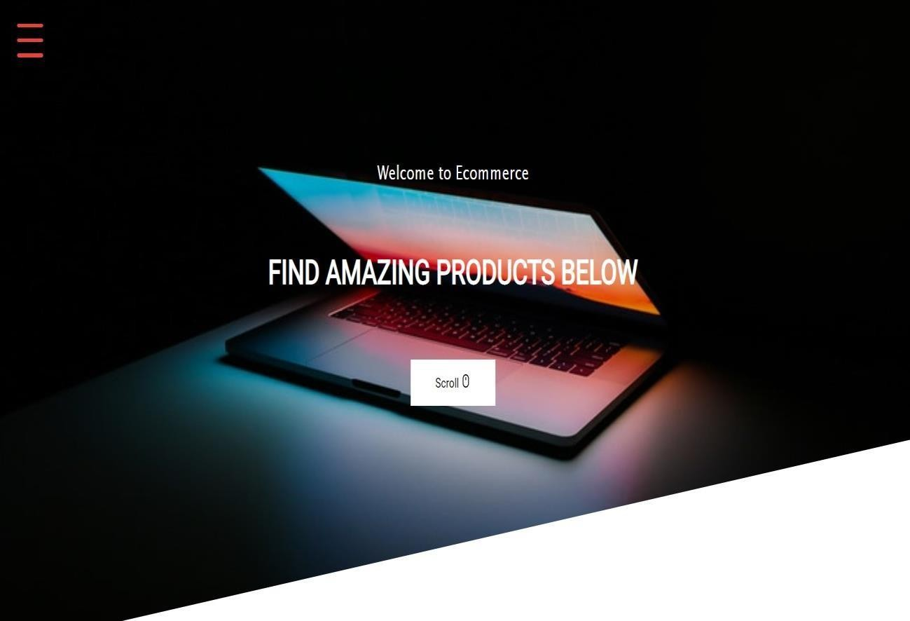

47

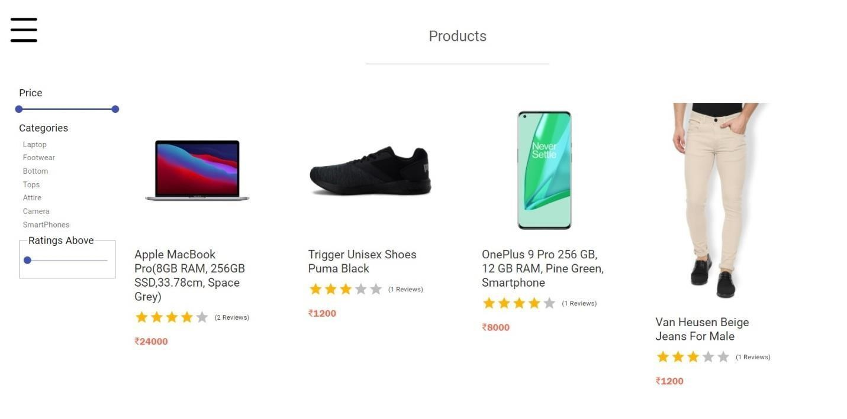

### Products Section

48

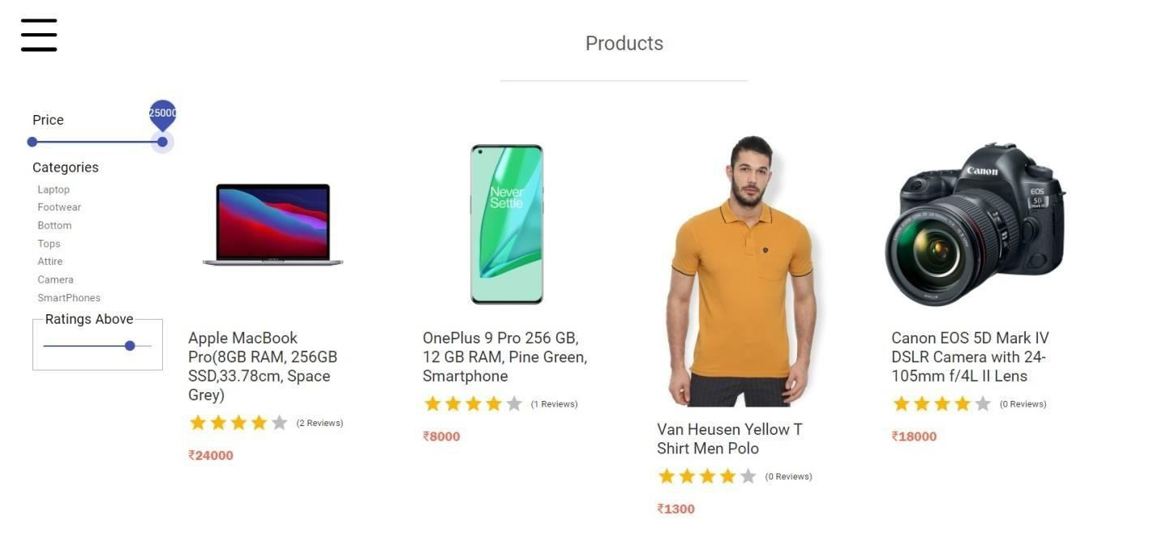

### Products Price Section

49

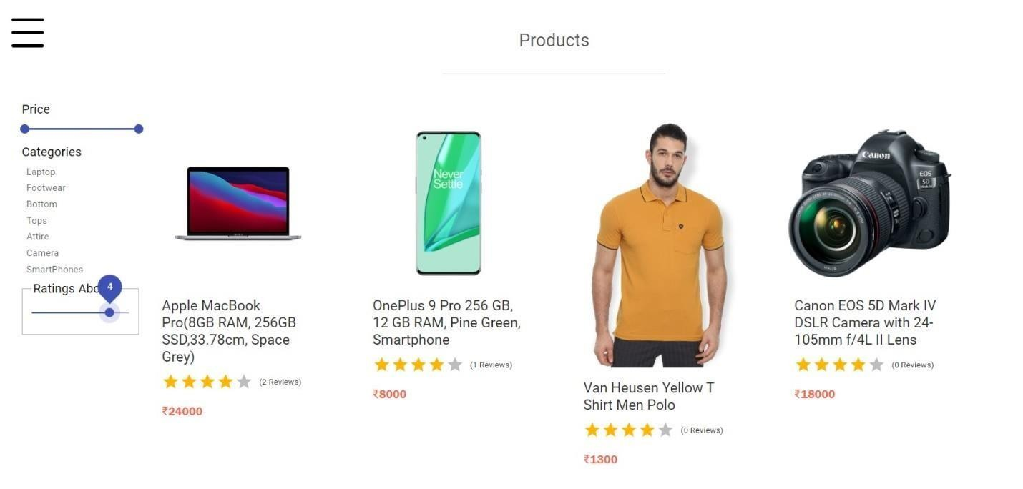

### Rating section

50

### Select the category

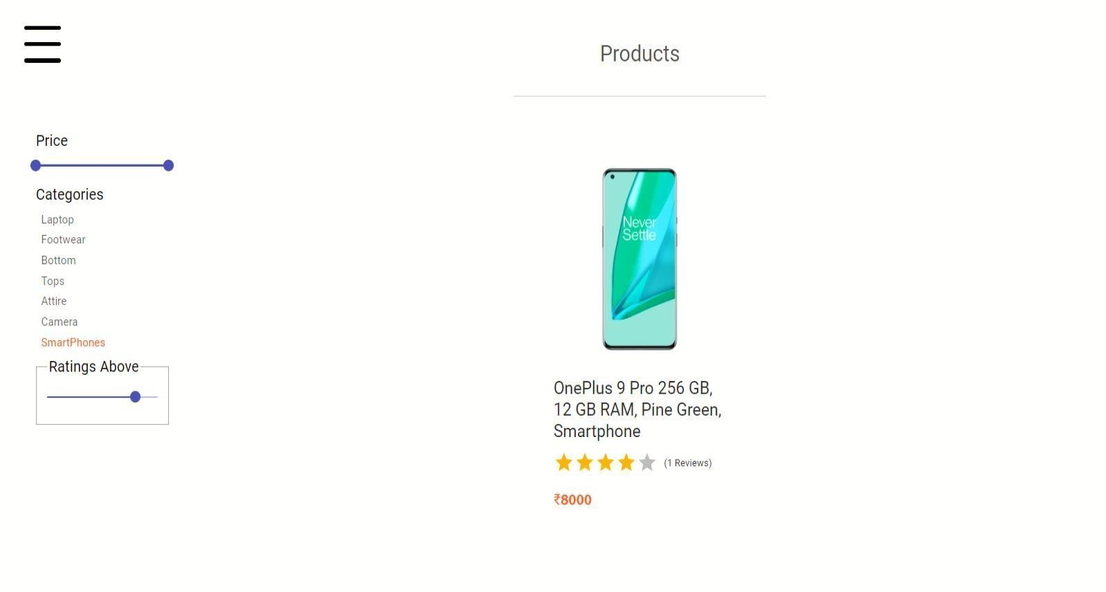

51

### Products Browsing

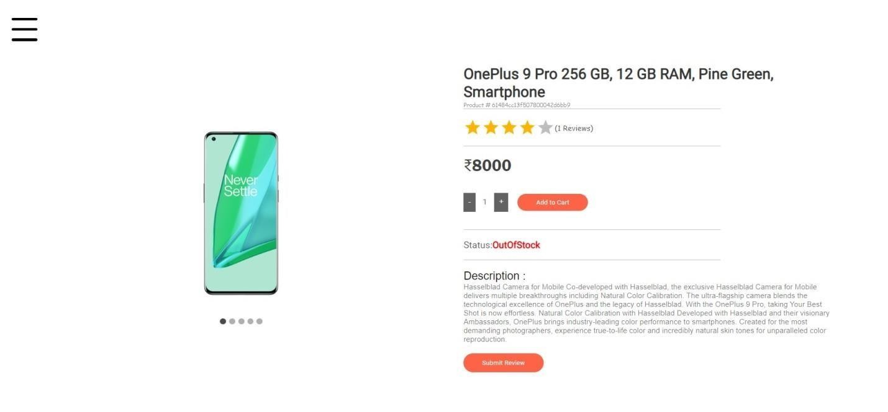

52

### Search products

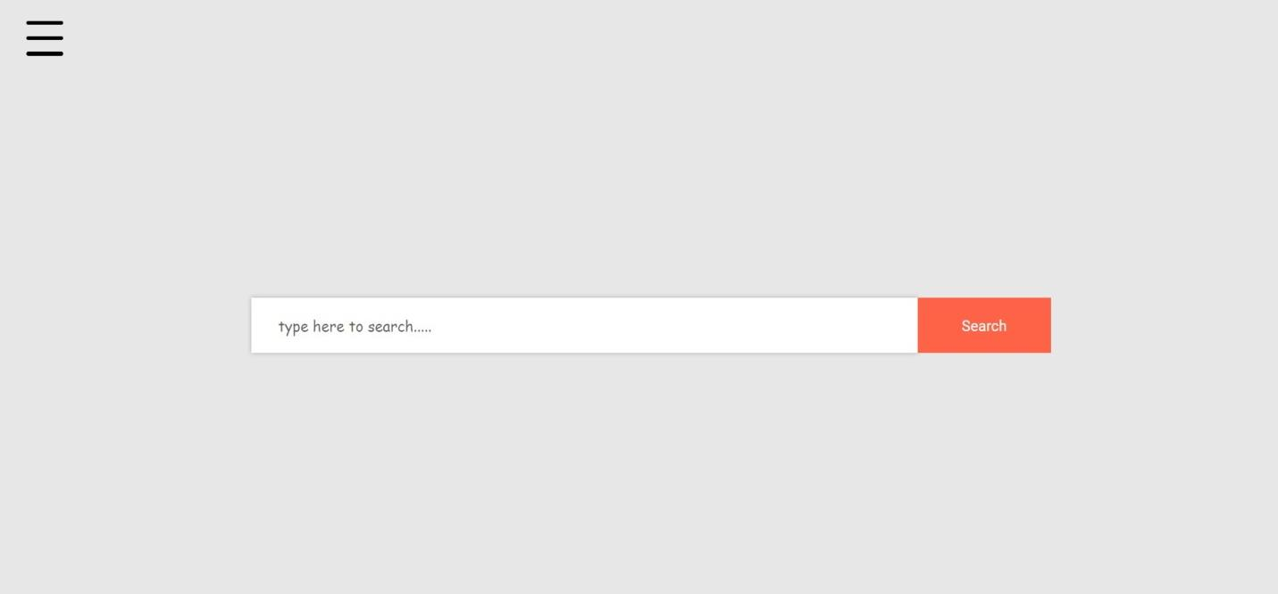

53

### Products Create by Admin

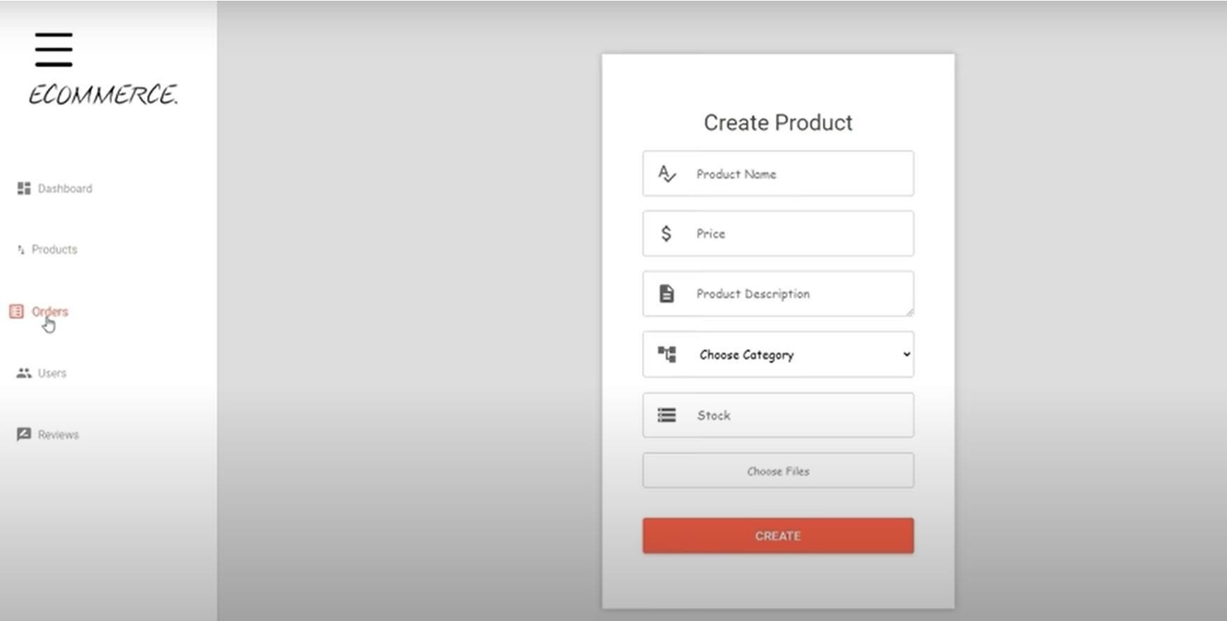

54

### Contact section

* + It could be beneficial to let your User’s decide what’s useful for them. It’s also helping the visitor tocontact the website owner.

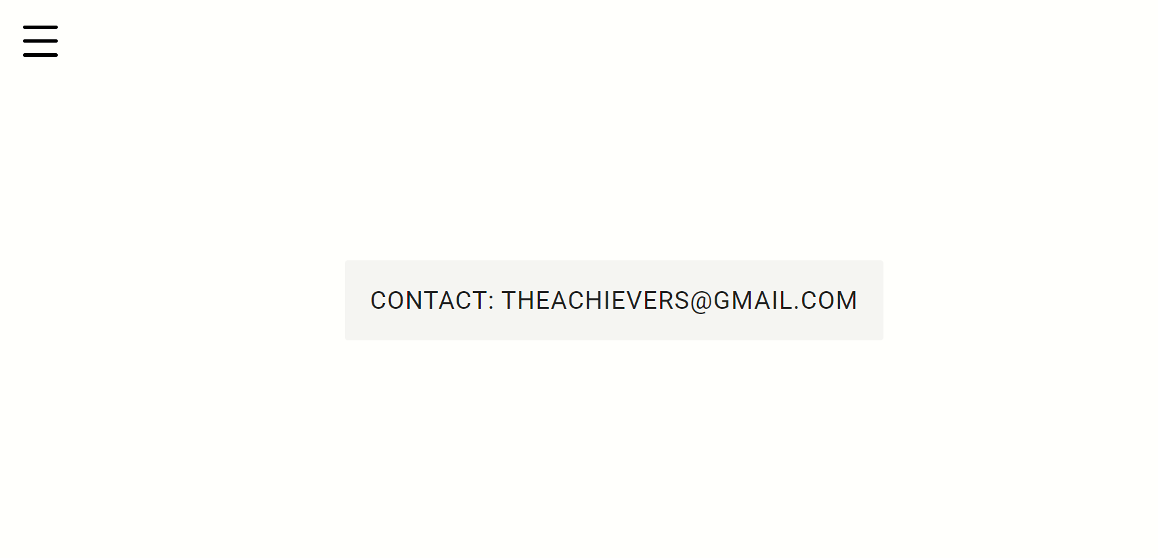

55

### About Section

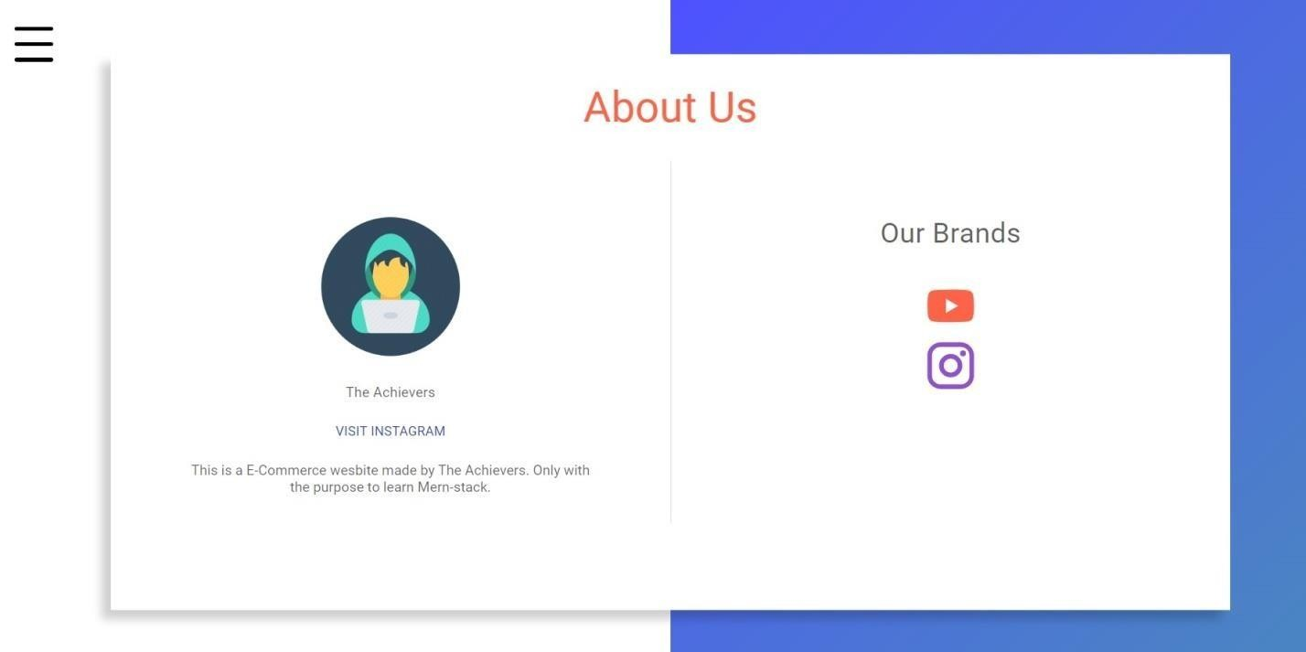

56

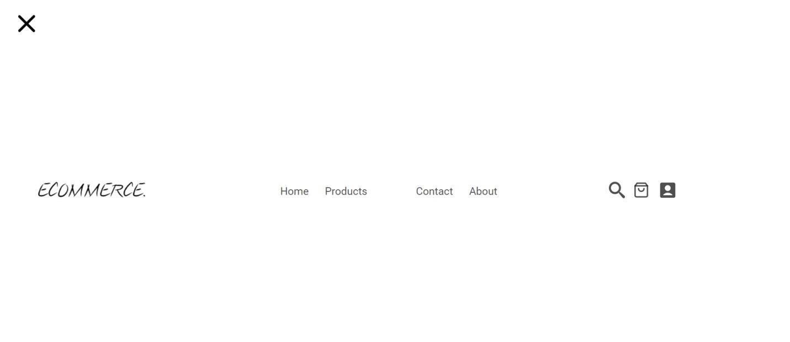

### Header

* Header is the top section of the web page. Headers are often the first thing site visitors see so havingthe logo is important.

57

### Footer

* The footer appears at the bottom of site page. it usually contains small-print items like copyright information and footer design is about choosing what to include, with the intention to helping visitors and meeting business goals.



58

## CHAPTER –6.

***Testing***

59

***Software testing***

**Software testing** is the act of examining the artifacts and the behavior of the software under test by validation and verification.

Software testing can also provide an objective, independent view of the software to allow the business to appreciate and understand the risks of software implementation. Test techniques include, but not necessarily limited to:

* Analyzing the product requirements for completeness and correctness in various contexts like industry perspective, business perspective, feasibility and viability of implementation, usability, performance, security, infrastructure considerations, etc.
* reviewing the product architecture and the overall design of the product
* working with product developers on improvement in coding techniques, design patterns, tests that can be written as part of code based on various techniques like boundary conditions, etc.
* executing a program or application with the intent of examining behavior.
* reviewing the deployment infrastructure and associated scripts & automation.
* take part in production activities by using monitoring & observability techniques.

60

* + Risks and Threats
* All this might make it sound as if your e-commerce business can’t possibly fail.
* Some risks are particularly relevant to e-commerce companies, such as:

1. Hacking
2. Credit card scams
3. Hardware failures
4. Unreliable shipping services
5. Software errors
6. Changing laws

61

## CHAPTER –7.

***Conclusion and Future Enhancements***

62

# Conclusion –

* + There are some essential factors which will contribute to the:
* e-commerce industry in India which includes E-Commerce services, multiple payment options, replacement guarantee, location based services, shipment optionsand quick services.Terms & Conditions should be clear and product quality should be the same as displayed on the sites.
* Today, it is a reality in India. In the last couple of years, the growth of E- commerce industry in India has been phenomenal as more shoppers have started discovering the benefits of using this platform.
* There is enough scopefor online businesses in the future.

63

***CHAPTER –8.***

***Bibliography***

64

* FUTURE SCOPE
  + Small stores going online, local marketing and branding may get a further scope.
  + Low operational costs and better quality of services.
  + Easy to start and manage a business**.**

###### BIBLIOGRAPHY

1. <http://en.wikipedia.org/wiki/Electronic_commerce>
2. [www.w3schools.com](http://www.w3schools.com/)
3. [http://www.ecommerce-blog.org](http://www.ecommerce-blog.org/)

65